Medium

🎓 Definition
# Source: ScreenShots Source: Provided by: [Persons Table -> ID Column: 1, Name_En Column: Motasem Essam] -> Tool: [Lightshot Program] -> From [Site: https://medium.com/] on [11/13/2025]
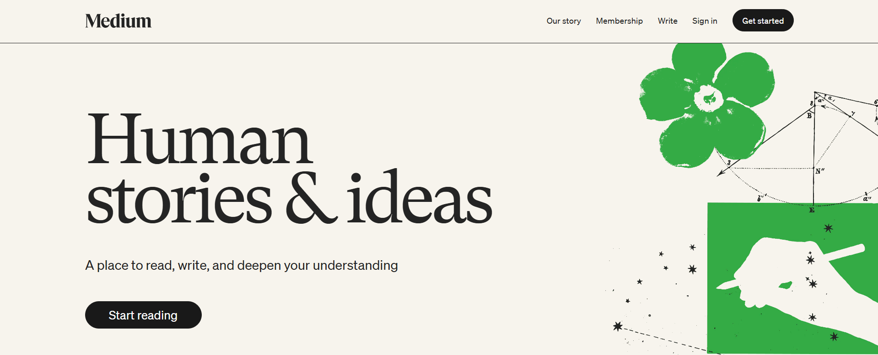
# Source: AI Source: Provided by: [Data Path: Persons Table -> ID Column: 1, Name_En Column: Motasem Essam] -> From: [ChatGPT] on [11/13/2025]
Medium (https://www.medium.com) is a public online publishing platform where individuals, organizations, and experts can share articles, essays, and stories. It’s not a traditional “news site” or “knowledge database” in the formal sense, but rather a platform for content creation and reading.
Here’s a breakdown:

🔹 Key Facts About Medium
# Source: AI Source: Provided by: [Data Path: Persons Table -> ID Column: 1, Name_En Column: Motasem Essam] -> From: [ChatGPT] on [11/13/2025]
- Founded: 2012 by Evan Williams (co-founder of Twitter)
- Purpose: To let people publish long-form content, ideas, and personal stories easily.
- Content Type: Articles, essays, opinion pieces, tutorials, guides, and more
- Audience: Writers, bloggers, journalists, and general readers interested in diverse topics
- Business Model: Free reading for many articles; optional Medium Membership for extra content
- Platform Type: Online publishing / blogging platform

🔹 How Medium Works
# Source: AI Source: Provided by: [Data Path: Persons Table -> ID Column: 1, Name_En Column: Motasem Essam] -> From: [ChatGPT] on [11/13/2025]
- Publishing: Anyone can create an account and publish stories.
- Reading: Free access to some articles; membership unlocks full access.
- Interaction: Readers can comment, “clap” (like), or share stories.
- Topics: Covers technology, culture, politics, health, science, personal development, and more.

🔹 Summary
# Source: AI Source: Provided by: [Data Path: Persons Table -> ID Column: 1, Name_En Column: Motasem Essam] -> From: [ChatGPT] on [11/13/2025]
- Medium is more like a digital magazine or publishing platform than a curated knowledge base.
- It hosts user-generated content rather than being a primary research or news source like ResearchResearch.

